Project report template

1 INTRODUCTION

1.1 Overview:

A scene showing,in this project explains about **INDIAN AGRICULTURAL CROP PRODUCTION(1997-2021).**This project is done in Tableau. It easily explains about agriculture of INDIA.Sheet,dashboard and story are the 3 tools used in it.

**1.2 Purpose:**

This project acquire the fundamental skills for analyzing Indian’s agriculture data in Tableau.

1. **PROBLEM DEFINITION & DESIGN THINKING**

**2.1 Empathy Map:**

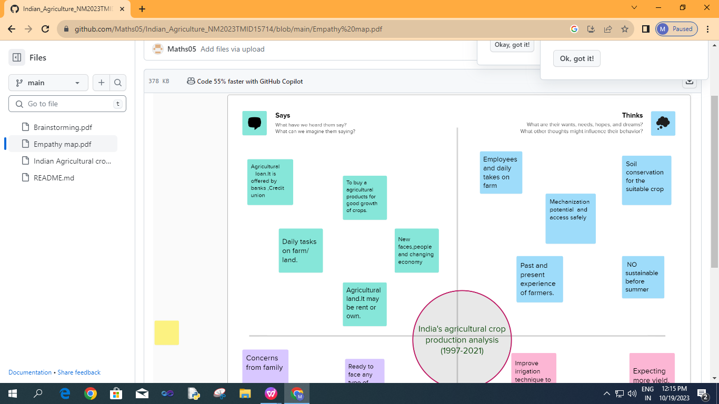

**2.2 Ideation & Brainstroming Map**

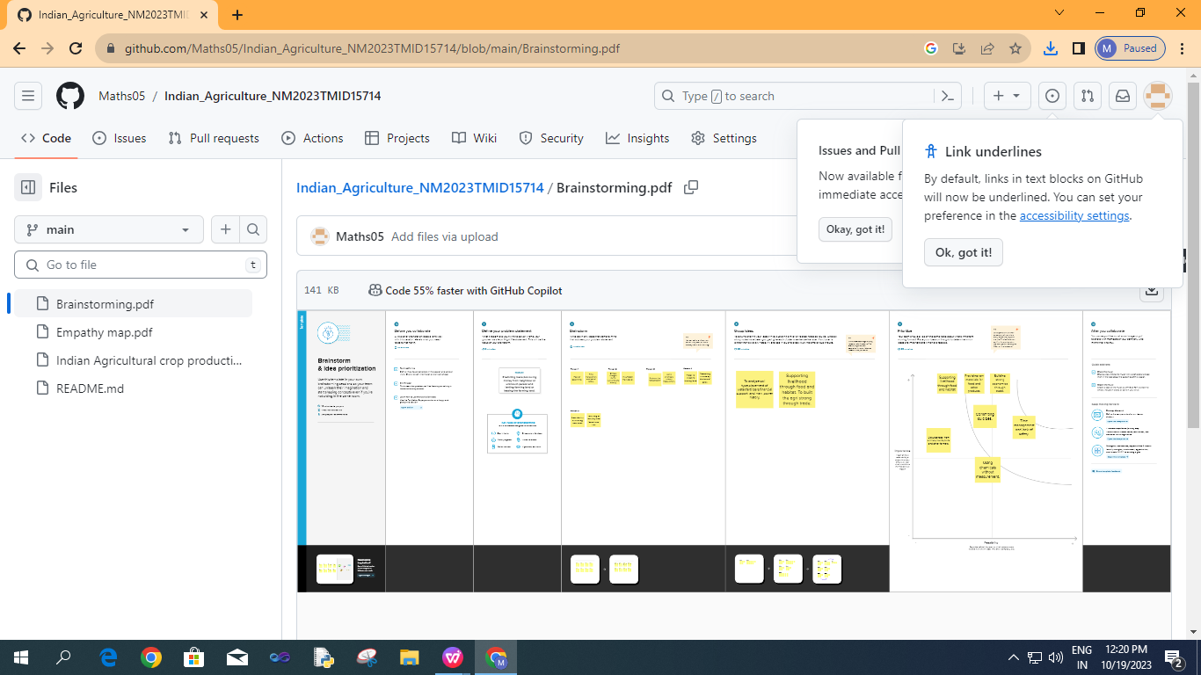

1. **RESULT**

**Final findings:**

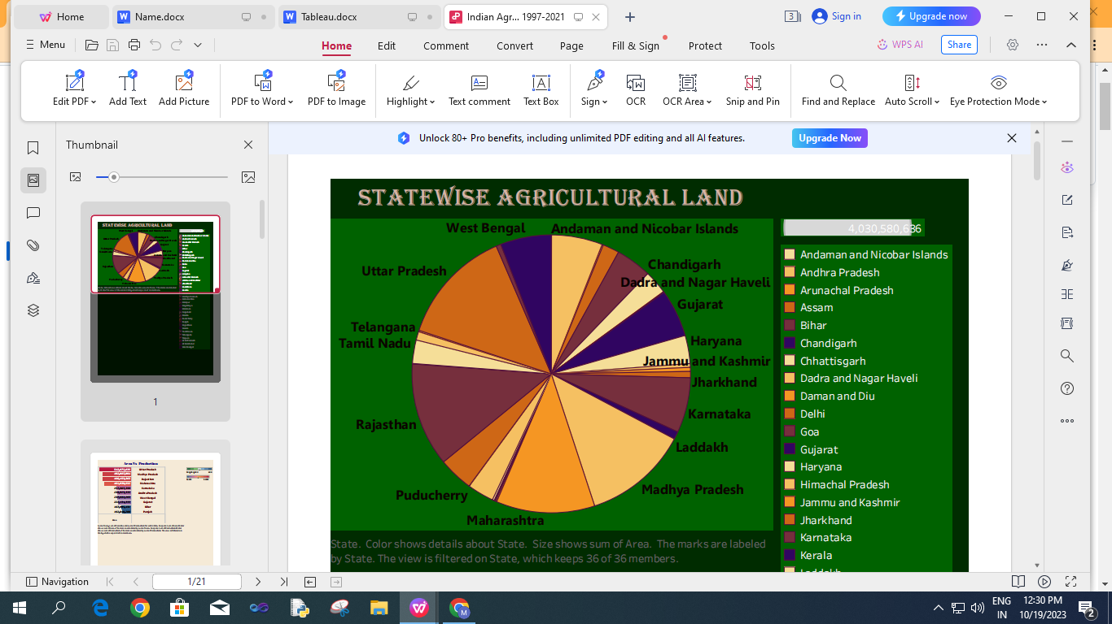

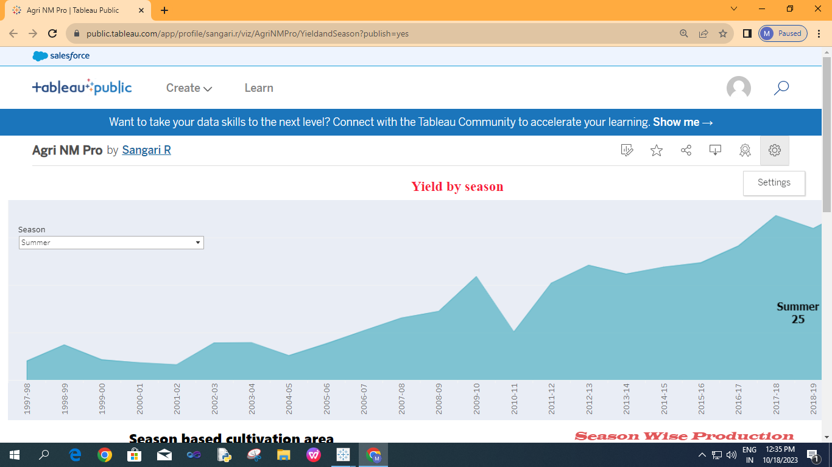

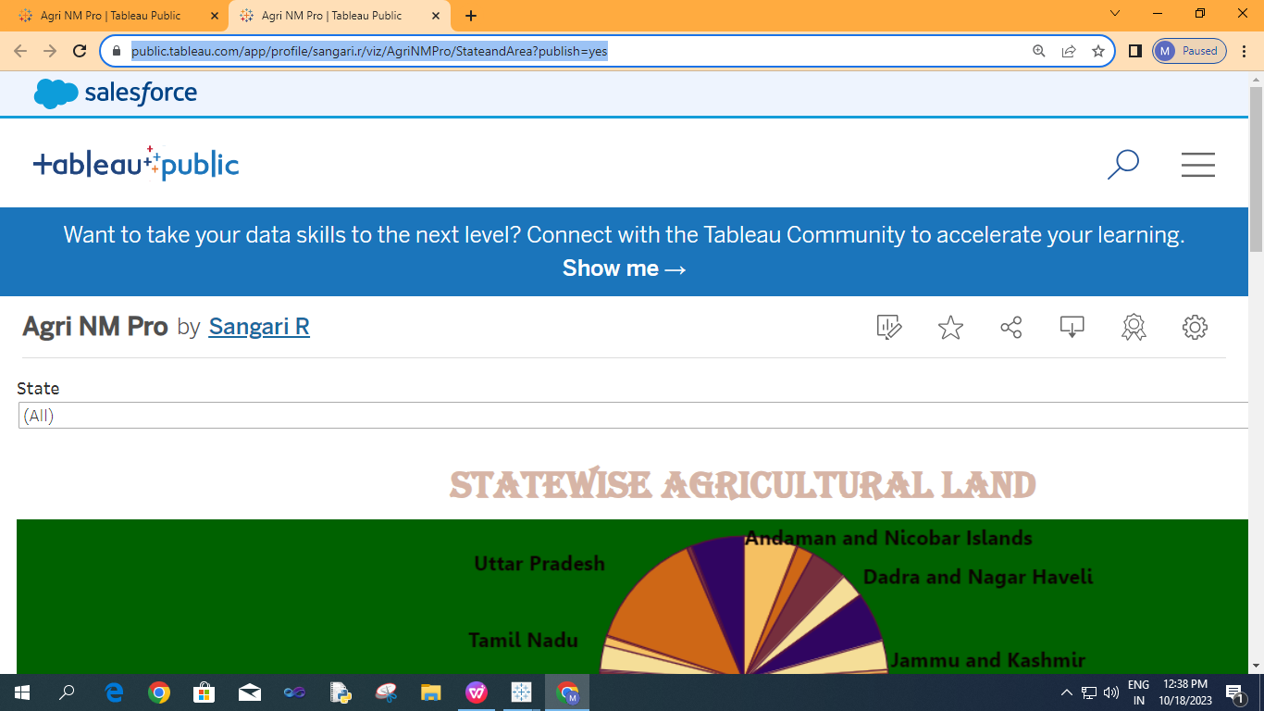

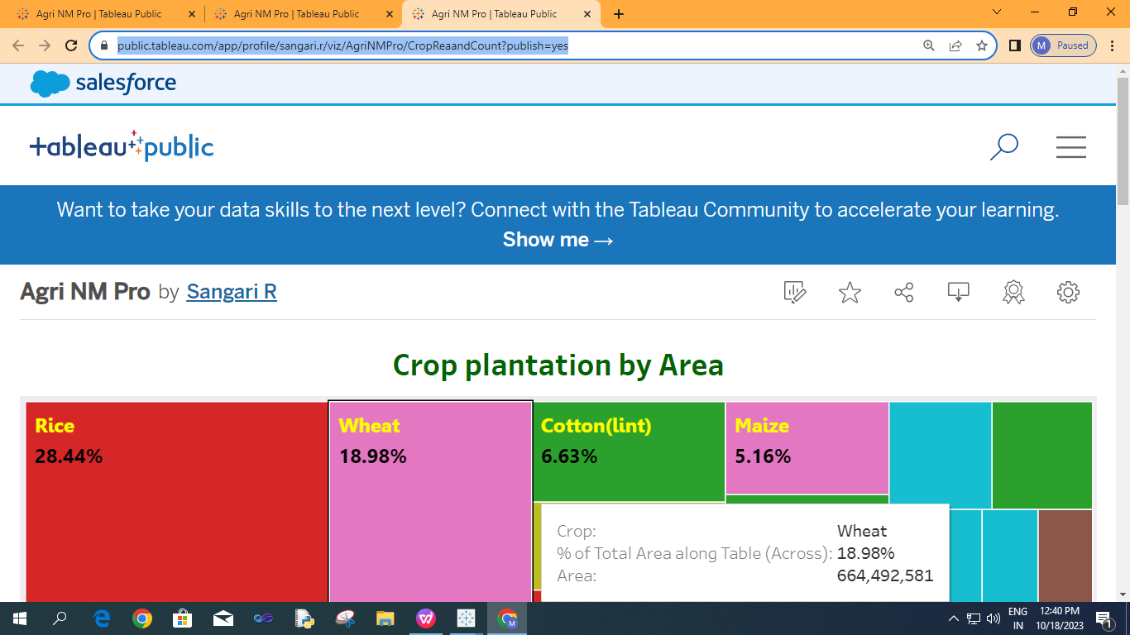

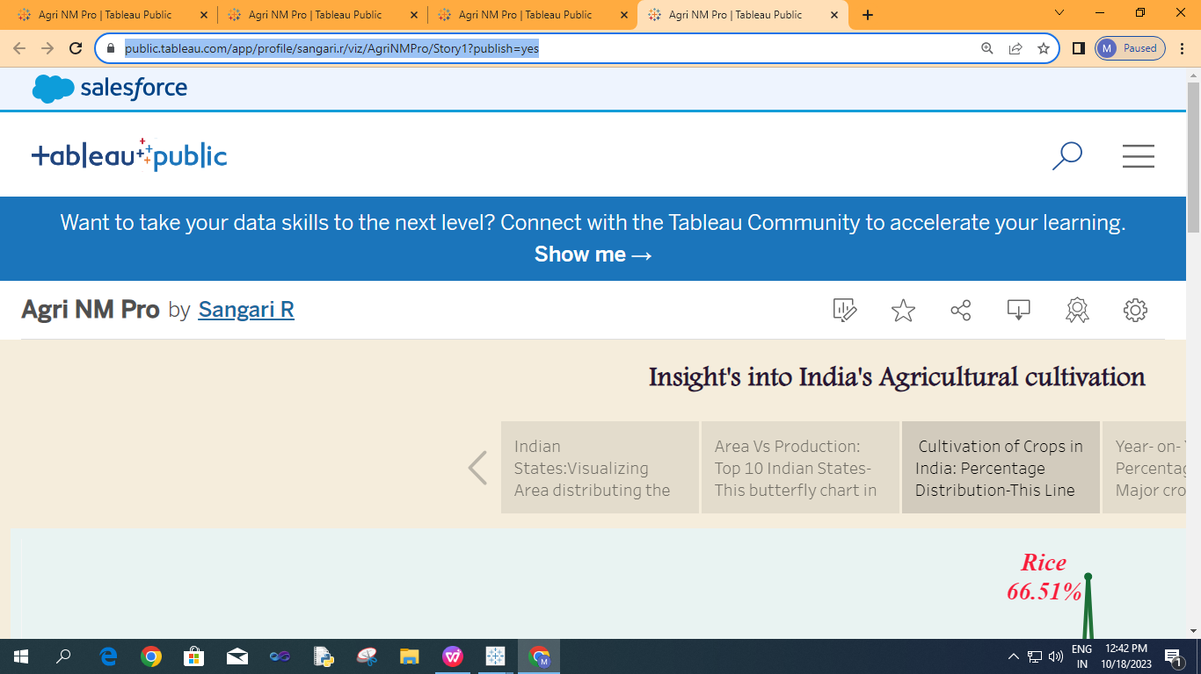

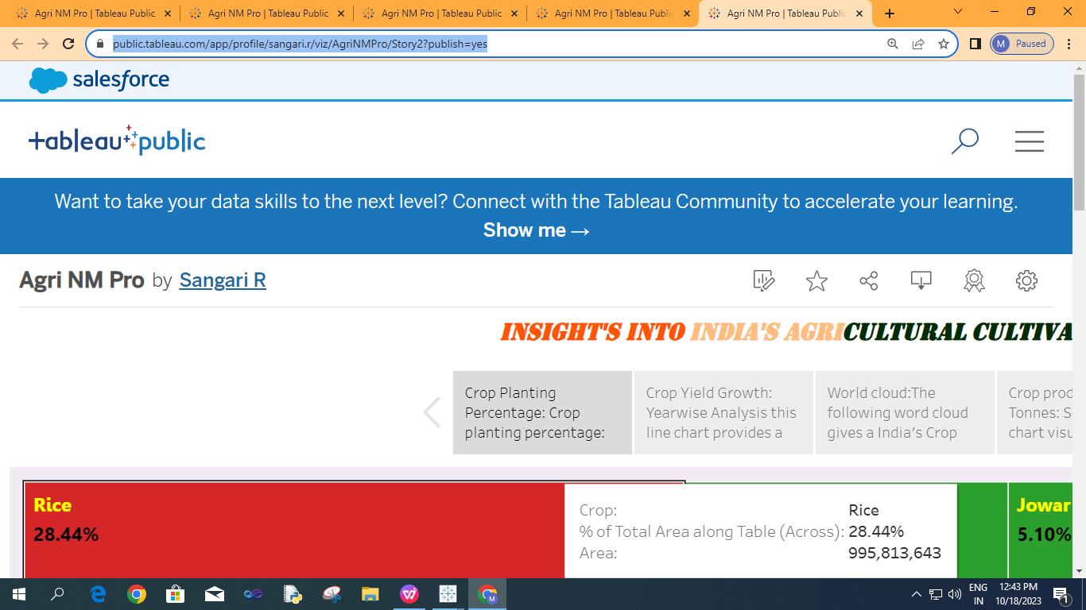

**4 ADVANTAGE AND DISADVANTAGE:**

**Advantage:**

1. Millions of rows of data can be handled with efficiency via Tableau.
2. Large amounts of data can be used to generate variety of visualization through charts by worksheet,dashboard and story.
3. Creating interactive data visualization and easily implementation.
4. Create visualization dragging and dropping on to the work area.
5. Trending in the market and ease to publishing and sharing.

**Disadvantage:**

1. It’s too expensive for some users.
2. Lack of functionality for scheduling via Tableau.
3. User still requires IT knowledge to get the best from the platform.
4. Need time to train to use this Tableau correctly.
5. Some of the functions are difficult to master quickly and it takes time for the freshers.

**5 APPLICATIONS**

To solve different agricultural problems, the Government of India has taken a number of steps like establishment of Indian Council of Agriculture Research (ICAR), agricultural universities, veterinary services and animal breeding centers, horticulture development, research and development in the field of meteorology and weather forecast, and grievances of the farmers.Agriculture solutions come in various formats such as satellite imagery, sensors, agriculture machines, and software solutions.

1. **CONCLUSION**

India’s agriculture has given so much to the society..Furthermore,the government is doing his every bite to help in the growth and development of INDIA’S AGRICULTURAL CROP PRODUCTION..Here our project is based on India’s Agricultural crop Production’s data set for the past 24 years(1997-2021).We made it in worksheet,dashboard and story.In this project there are 8 sheets,3 dashboards and 2 stories.State wise agricultural land,Area vs production,season based cultivation area,yield by season,crop plantation by area,crop plantation by count,Season wise production,Major crops&crop plantation by count in worksheets.first 2 sheets are compared in 1dashboard,next 3 in dashboard and last 3 in dashboard.Finally 2 stories are created via tableau.

1. **FUTURE SCOPE**

The increased agricultural production, Generating employment Reducing,Poverty to equitable and sustainable growth.

Future agricultural will use sophisticated technologies such as robots, temperature and moisture sensors, aerial images, and GPS technology.